**Giovanni Buttarelli: in memoriam**

Rights areas:

* [Data protection, privacy and new technologies](https://fra.europa.eu/en/taxonomy/term/969)

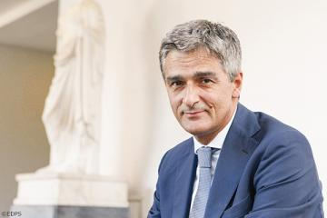

It is with great sadness that the European Union Agency for Fundamental Rights learned about the death of Giovanni Buttarelli, the European Data Protection Supervisor.

“Giovanni Buttarelli was a true champion of data protection at a time of unprecedented change in the use of information and communication technologies worldwide. His intellect and passion for the European Union and its values serve as an inspiration to us all,” said the agency’s Director Michael O’Flaherty. “He will be sorely missed by the agency and the data protection community at large.”

Giovanni Buttarelli was appointed as European Data Protection Supervisor in 2014 after serving as assistant European Data Protection Supervisor from 2009. Before that, he was the Secretary General at the Italian Data Protection Authority for 12 years and worked for many years with the Italian judiciary.

The Fundamental Rights Agency would like to acknowledge Giovanni Buttarelli’s valuable contribution to strengthening data protection in Europe and beyond, and sends its sincere condolences to his family.